**Phase 3**

**SQL Operations**

3.1 Insert records from 42_District_wise_crimes_committed_against_women_2001_2012.csv into a table.

Syntex:

Create Database Women;

Table data import wizard

Upload data

select * from women;

3.2 Write SQL query to find the highest number of rapes & Kidnappings that happened in which state, District, and year.

Syntex: Highest no. of rapes

SELECT STATE_UT, district, year, rape FROM women

order by rape desc;

Output -

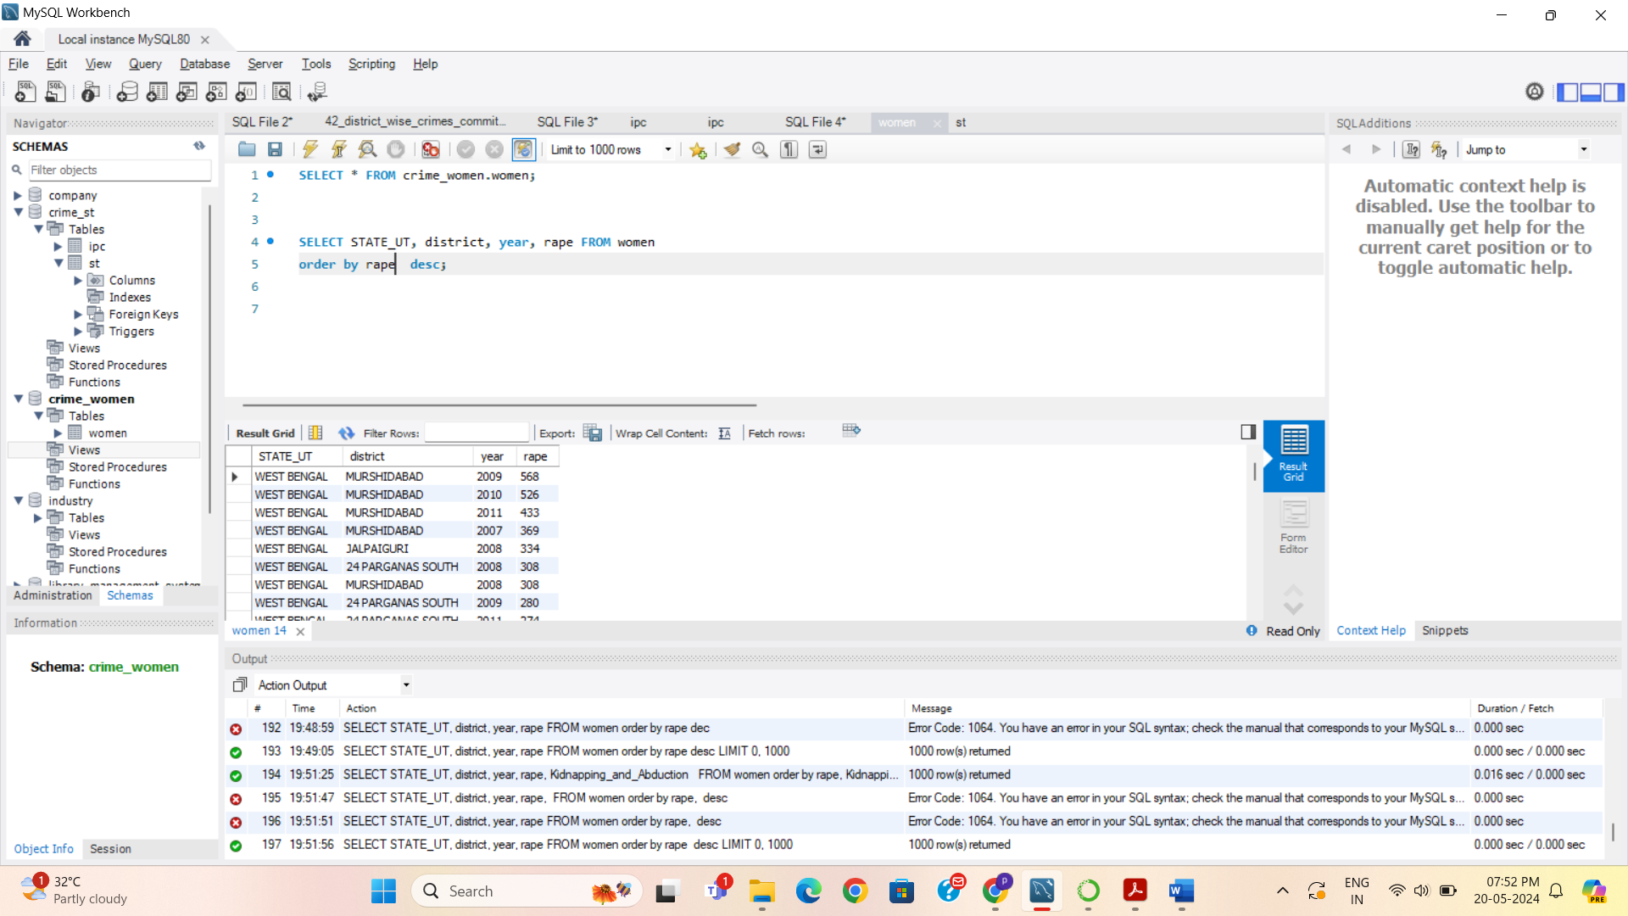

Syntex: Highest no. of Kidnapping

SELECT STATE_UT, district, year, Kidnapping_and_Abduction FROM women

order by Kidnapping_and_Abduction desc;

Output –

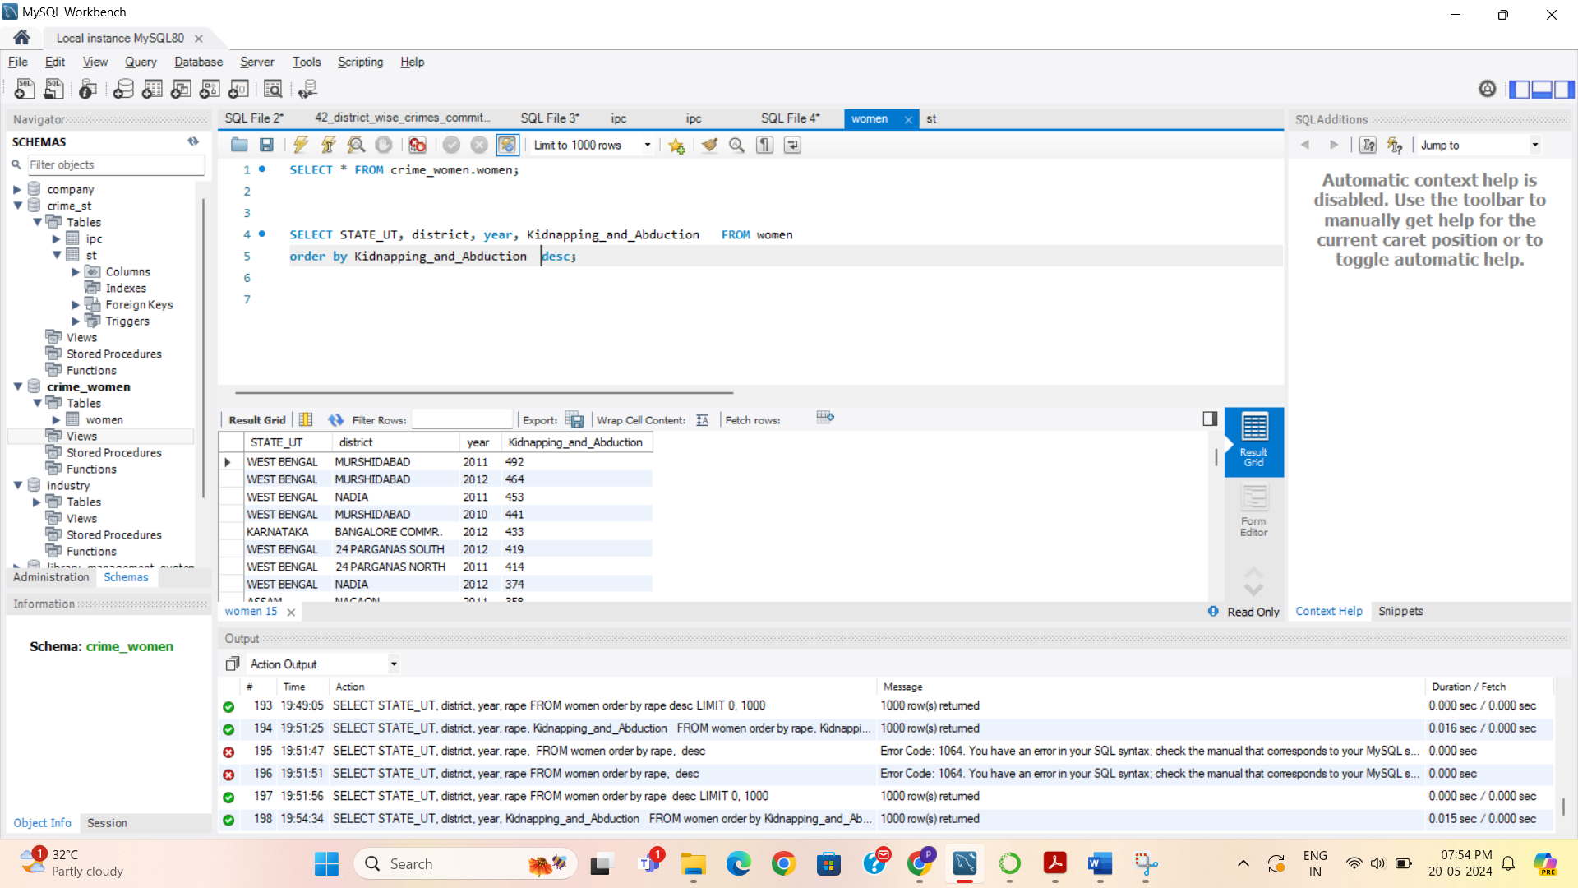

3.3 Write SQL query to find All the lowest number of rapes & Kidnappings that happened in which state, District, and year.

Syntex: Lowest no. of rapes

SELECT STATE_UT, district, year, rape FROM women

WHERE rape = (

SELECT min(rape) FROM women

);

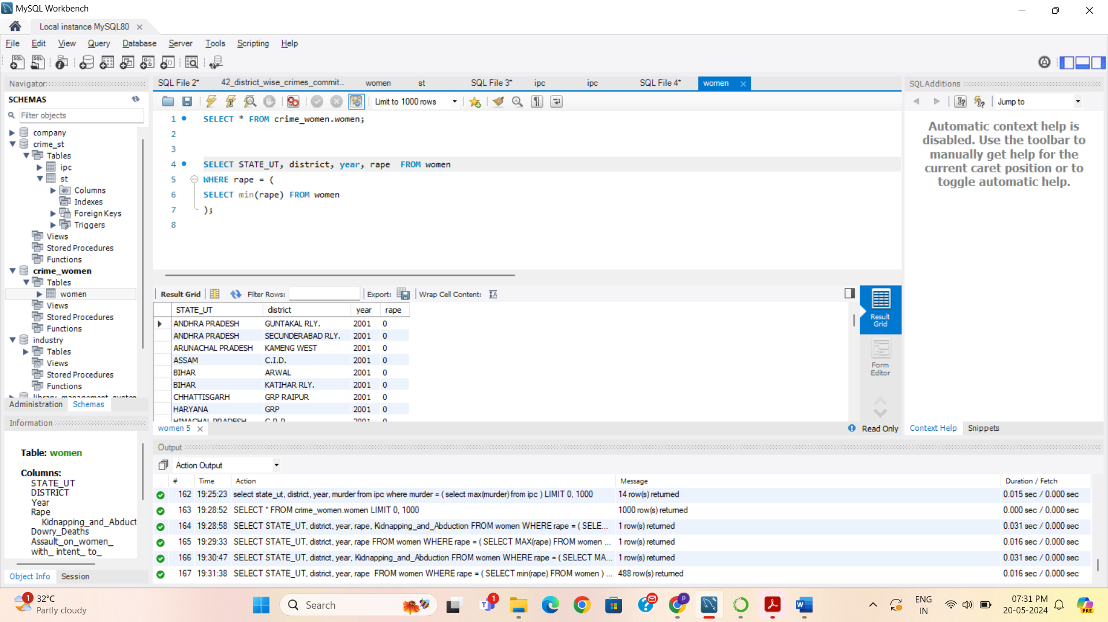

Syntex: Highest no. of Kidnapping

SELECT STATE_UT, district, year, Kidnapping_and_Abduction FROM women

WHERE Kidnapping_and_Abduction = (

SELECT min(Kidnapping_and_Abduction ) FROM women

);

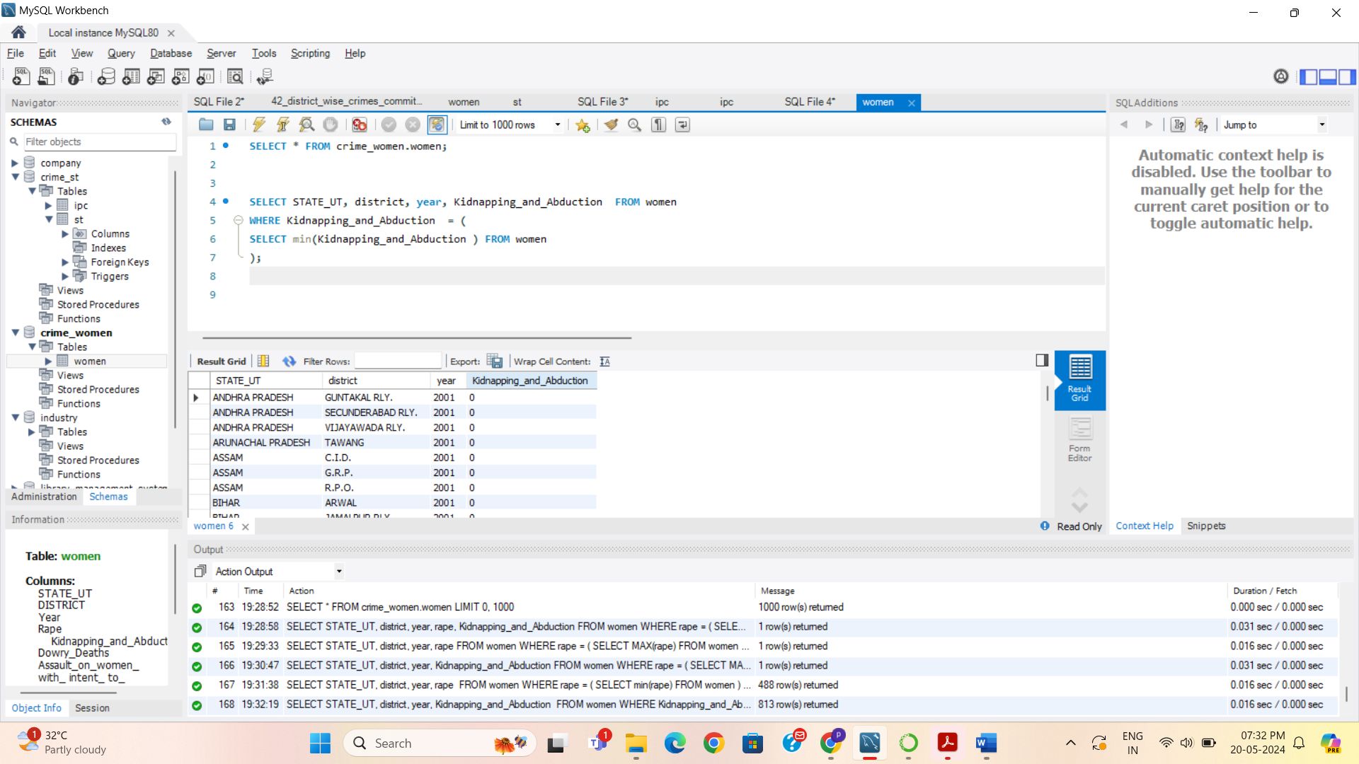

3.4 Insert records from 02_District_wise_crimes_committed_against_ST_2001_2012.csv into a new table

Steps:

Create Database crime_st

Table data import wizard

Upload data

select * from st;

3.5 Write SQL query to find the highest number of dacoity/robbery in which district.

Syntex: Highest no. of Dacoity

SELECT district, dacoity FROM st

order by dacoity desc;

);

Output:

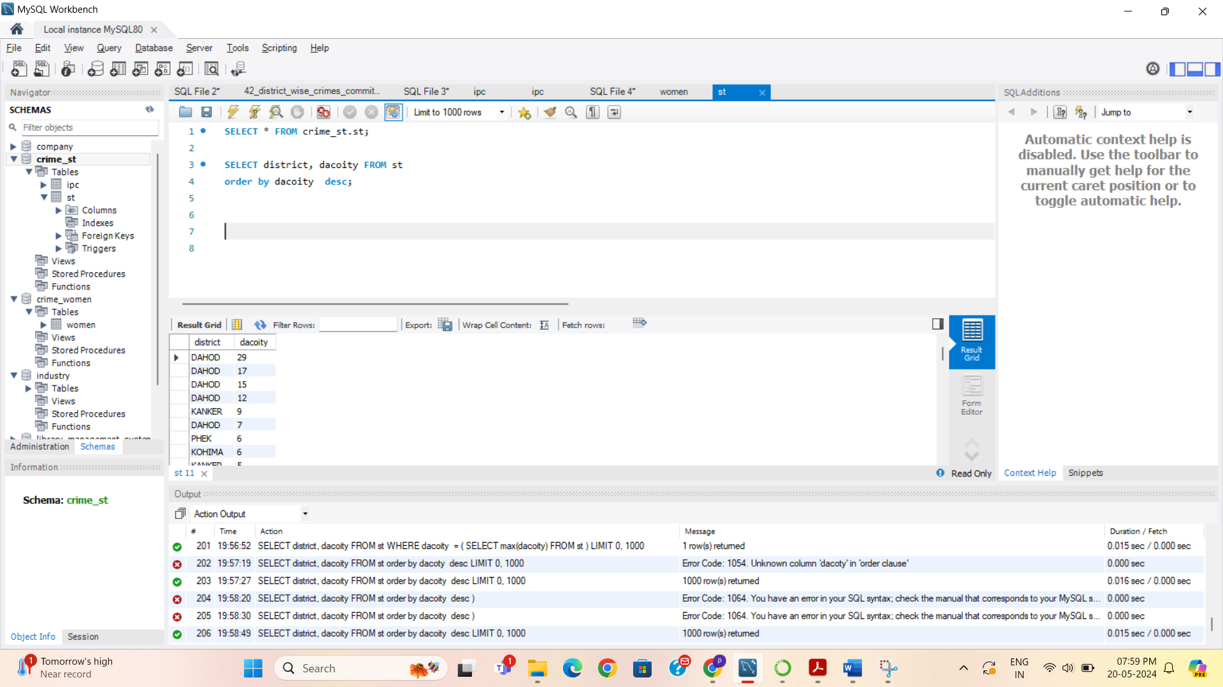

Syntex: Highest no. of Robbery

SELECT district, robbery FROM st

order by robbery desc;

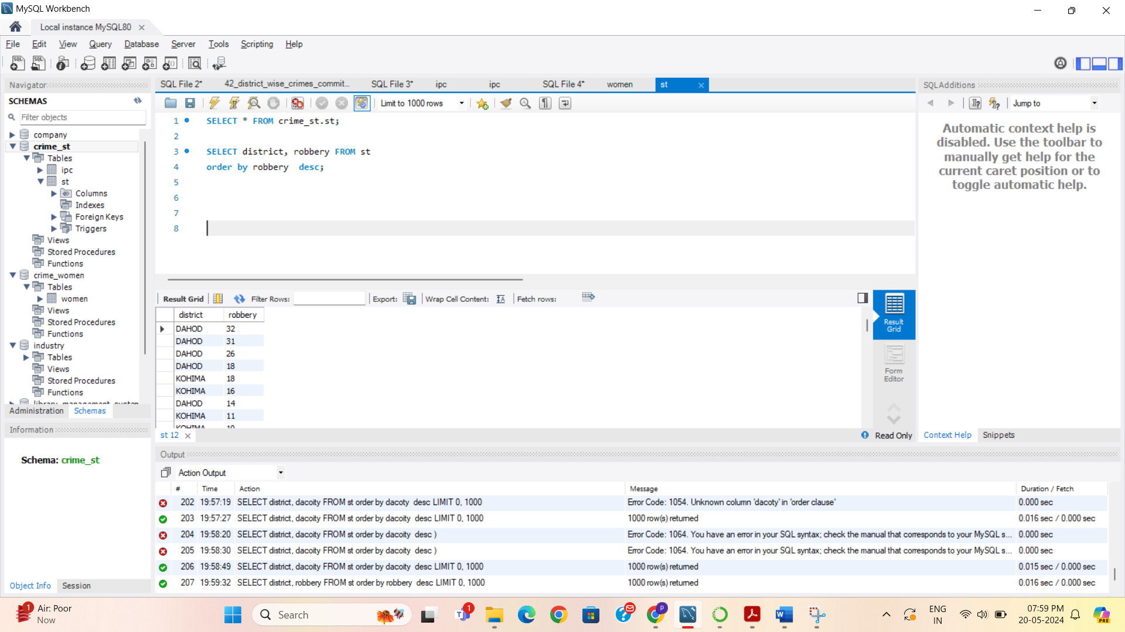

3.6 Write SQL query to find in which districts(All) the lowest number of murders happened.

Syntex: Lowest no. of Murder in districts

SELECT STATE_UT, district, murder FROM st

WHERE murder = (

SELECT min(murder) FROM st

);

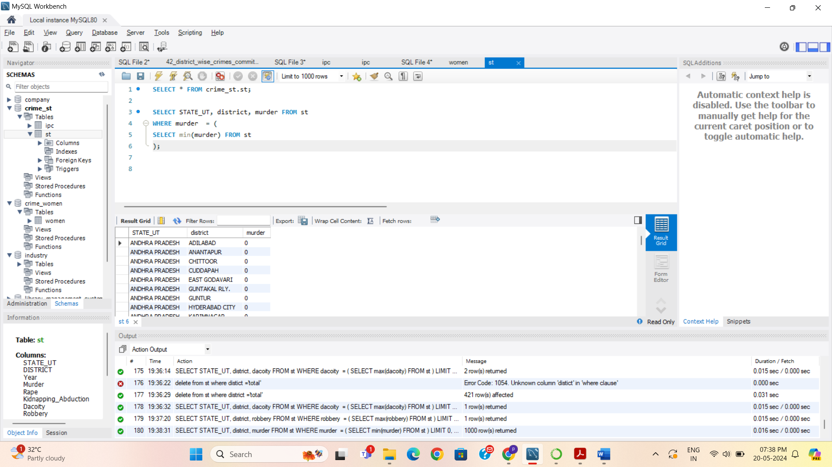

3.7 Write SQL query to find the number of murders in ascending order in district and year wise.

Syntex: No. of Murder in Ascending order

SELECT district ,year, murder FROM st

order by murder asc;

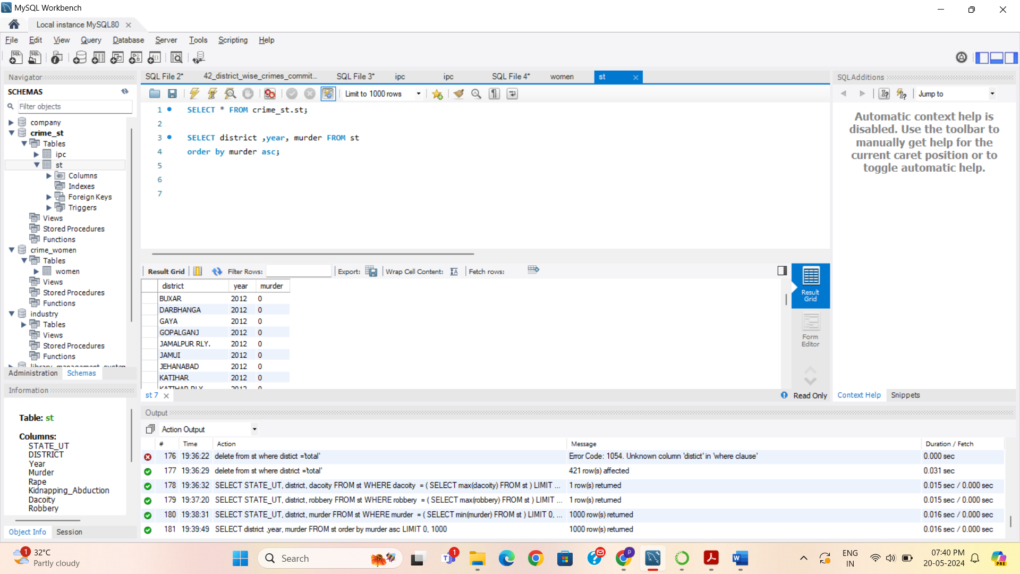

3.8.1 Insert records of STATE/UT, DISTRICT, YEAR, MURDER, , and RAPE columns only from 01_District_wise_crimes_committed_IPC_2001_2012.csv into a new table.

Syntex: Inserting records from specific columns.

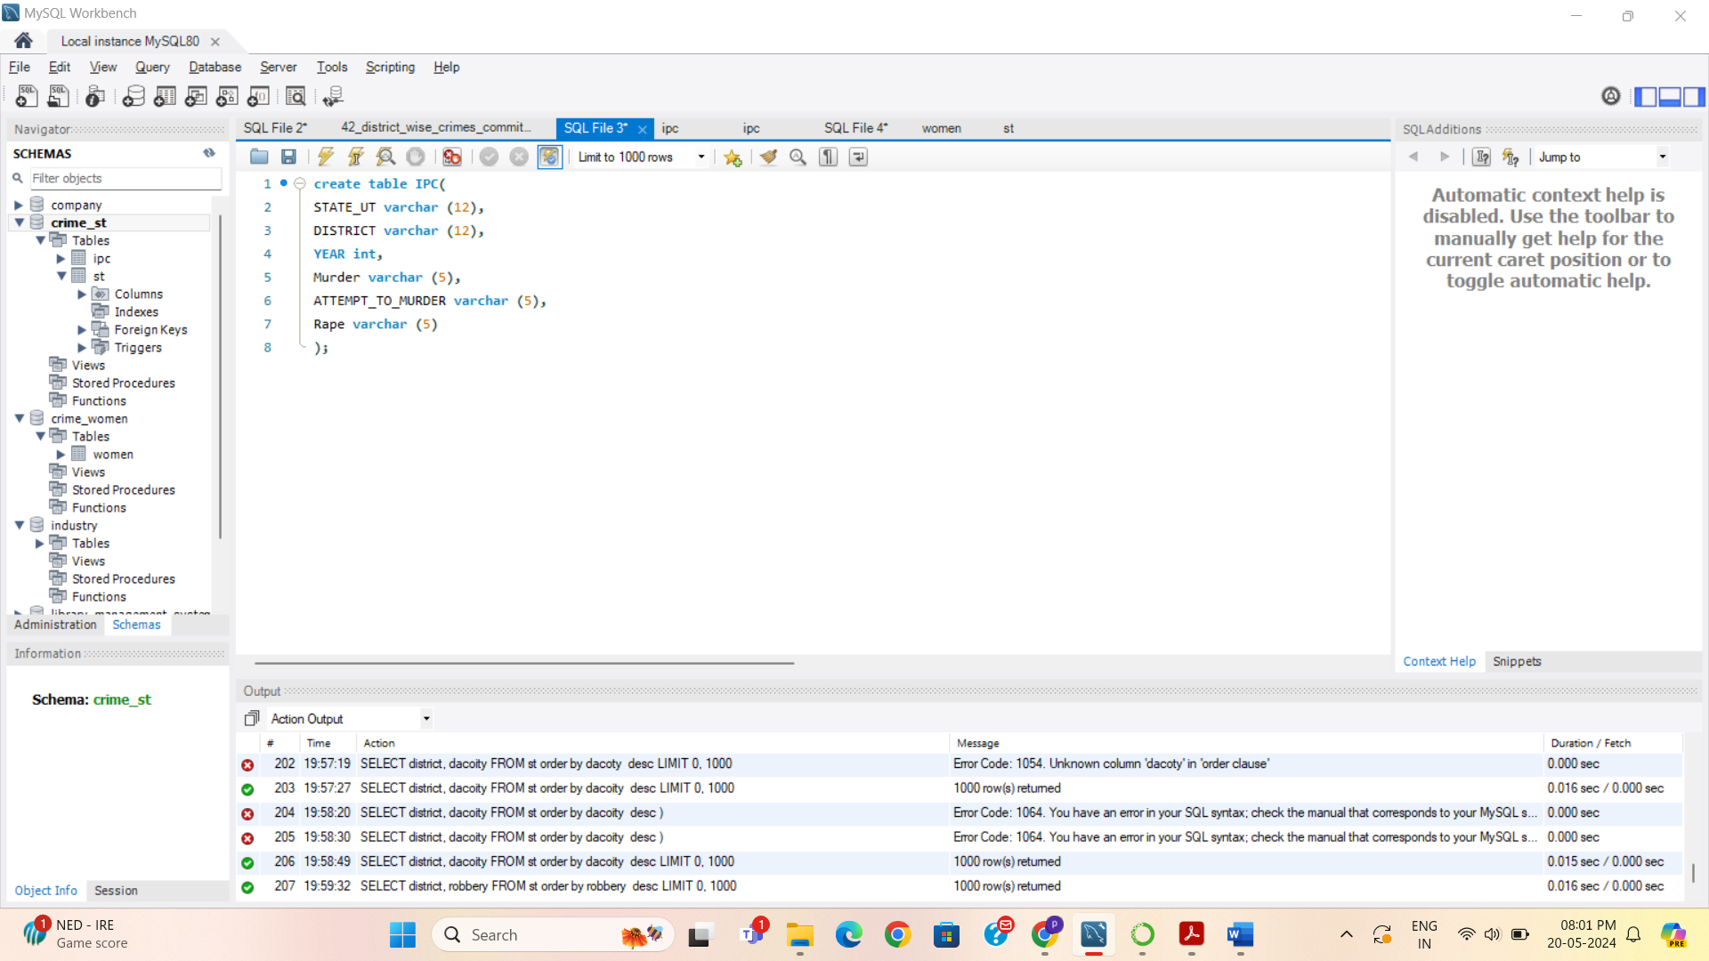

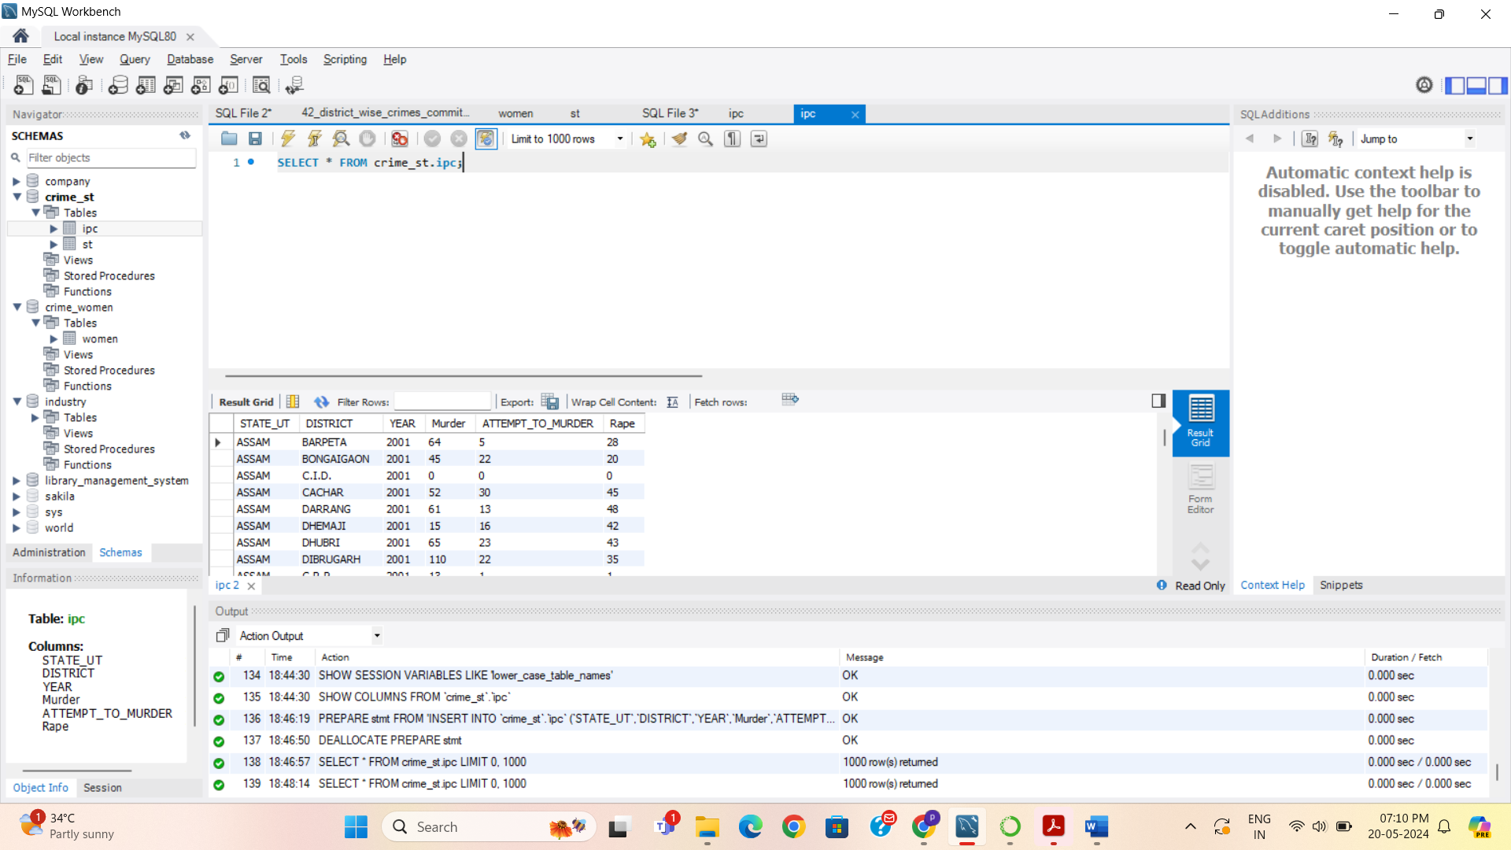

3.8.2 Write SQL query to find which District in each state/UT has the highest number of murders year wise. Your output should show STATE/UT, YEAR, DISTRICT, and MURDERS.

Output:

select state_ut, district, year, murder from ipc

where murder =

( select max(murder)

from ipc

);

